Technical Documentation

Dark Ascent

Turkish Van

Stephen Aldred

Noelle Alston

Peter Gatira

Bhojraj Pandey

CMSC 447: Software Engineering I

Dr. Nick Allgood

# Class Diagram

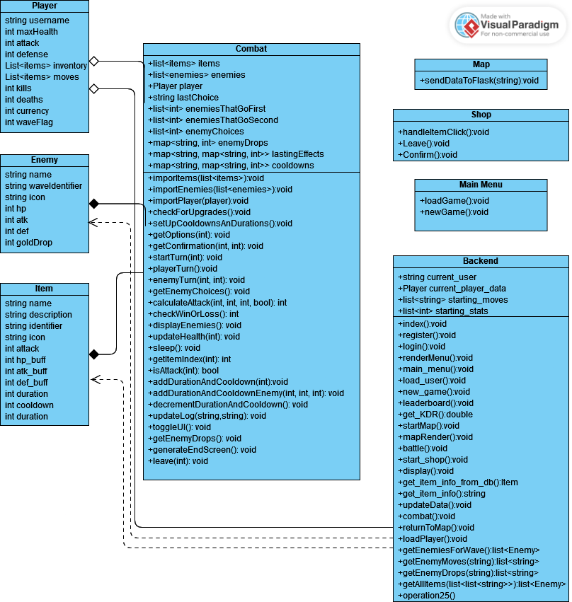

# Database Design

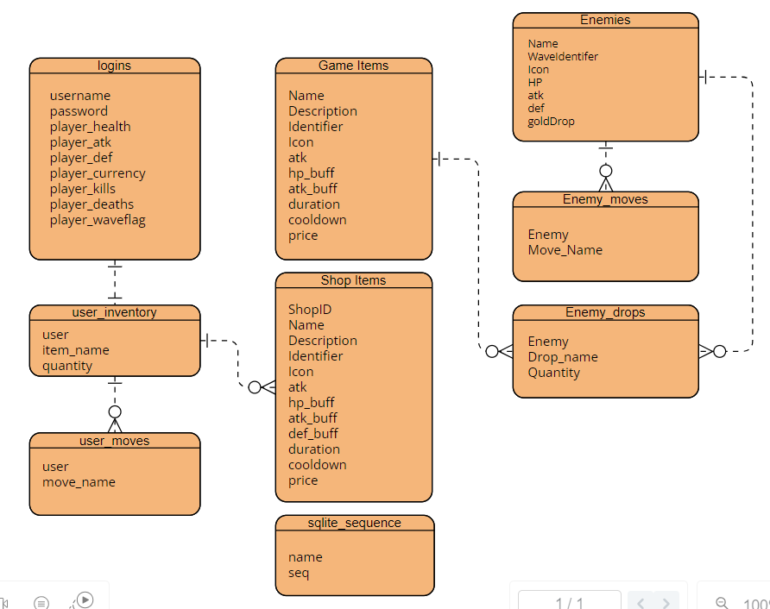

# 

# API Calls

* New Game
  + Purpose: resets game assets and player items
  + Method: POST
  + Request: { userId: 'user123'}
  + Response: redirects to the map
  + Error codes: 404 - page not found, 405- method is not supported, 500 - internal server error
* Load Game
  + Purpose: load saved game assets and player items
  + Method: POST
  + Request: { userId: 'user123'}
  + Response: redirects to the map
  + Error codes: 404 - page not found, 405- method is not supported, 500 - internal server error
* Start Battle
  + Purpose: loads combat and allows users to fight enemies
  + Method: POST
  + Request: { buttonId: buttonId }
  + Response: redirects to combat
  + Error codes: 404 - page not found, 405- method is not supported, 500 - internal server error
* Start Shop
  + Purpose: loads shop and allows players to purchase items
  + Method: POST
  + Request: { buttonId: buttonId }
  + Response: redirects to shop
  + Error codes: 404 - page not found, 405- method is not supported, 500 - internal server error
* Render menu
  + Purpose: allows users to return to the main menu if they so choose
  + Method: POST
  + Request: { buttonId: buttonId }
  + Response: redirects to the main menu
  + Error codes: 404 - page not found, 405- method is not supported, 500 - internal server error
* ReturnToMap
  + Purpose: Allows the user to return to the map during and after combat
  + Method: POST
  + Request: { condition: winLossOrRun, kills: numKilled, inventory: jsonibleInventory}
  + Response: redirects to the main menu
  + Error codes: 404 - page not found, 405 - method is not supported, 500 - internal server error
* Register
  + Purpose: Allows the user to register their username and password in order to play the game
  + Method: GET
  + Request: { id = "username",id = "password"}
  + Response: redirects to the login so the user can use their new credentials
  + Error codes: 404 - page not found, 405 - method is not supported, 500 - internal server error
* GetItemInfo
  + Purpose: Allows the user to click an item and get the information about it
  + Method: GET
  + Request: { id = imageID}
  + Response: reformats the shop page to include the information about the clicked item
  + Error codes: 404 - page not found, 405 - method is not supported, 500 - internal server error
* Leave
  + Purpose: Allows the user to return to the map after shopping
  + Method: POST
  + Request: { userId: 'user123'}
  + Response: redirects to the main menu
  + Error codes: 404 - page not found, 405 - method is not supported, 500 - internal server error
* Confirm
  + Purpose: Allows the user to purchase items while shopping. Updates the players currency and inventory
  + Method: POST
  + Request: { userId: 'user123'}
  + Response: reformats the new currency on the screen
  + Error codes: 404 - page not found, 405 - method is not supported, 500 - internal server error